

Institute of Engineering & Technology

JK Lakshmipat University

**Lab Record**

Course: AS1113 Optimization for Computer Science

FACULTY GUIDE: Dr. Jaya Gupta

SUBMITTED BY: Siddhi Nyati

(2022Btech101)

**Index:**

|  |  |  |  |
| --- | --- | --- | --- |
| **LAB NO.** | **OBJECTIVE** | **DATE** | **PAGE NO.** |
| 1 | 1.) To explore Operational research books and solve the problem of LPP.  2.) The application of linear programming problems to health care. | 11/01/24 | 3-7 |
| 2 | Solving LPP using Tora software | 18/01/24 | 8-14 |
| 3 | Solving linear programming problems using Python. | 25/01/24 | 15-16 |
| 4 | Solving non-linear programming problem (Hessian matrix) using python | 01/02/24 | 17 - 18 |
| 5 | Check convex or concave using python | 08/02/24 | 19 |
| 6 | Analyzing Non-linear programming using the Lagrangian method through a research paper | 22/02/24 | 20-21 |
| 7 | Minimization of function by Golden section method using Python. | 07/03/24 | 22-23 |
| 8 | Fibonacci method | 28/03/24 | 24-25 |
| 9 | Steepest descent method and newton search method | 04/04/24 | 26-27 |
| 10 | Conjugate Search Method | 11/04/24 | 28 |

*Date: 11/01/24*

**LAB ACTIVITY 1**

1.) To explore Operational research books and solve the problem of LPP.

2.) The application of linear programming problems to health care.

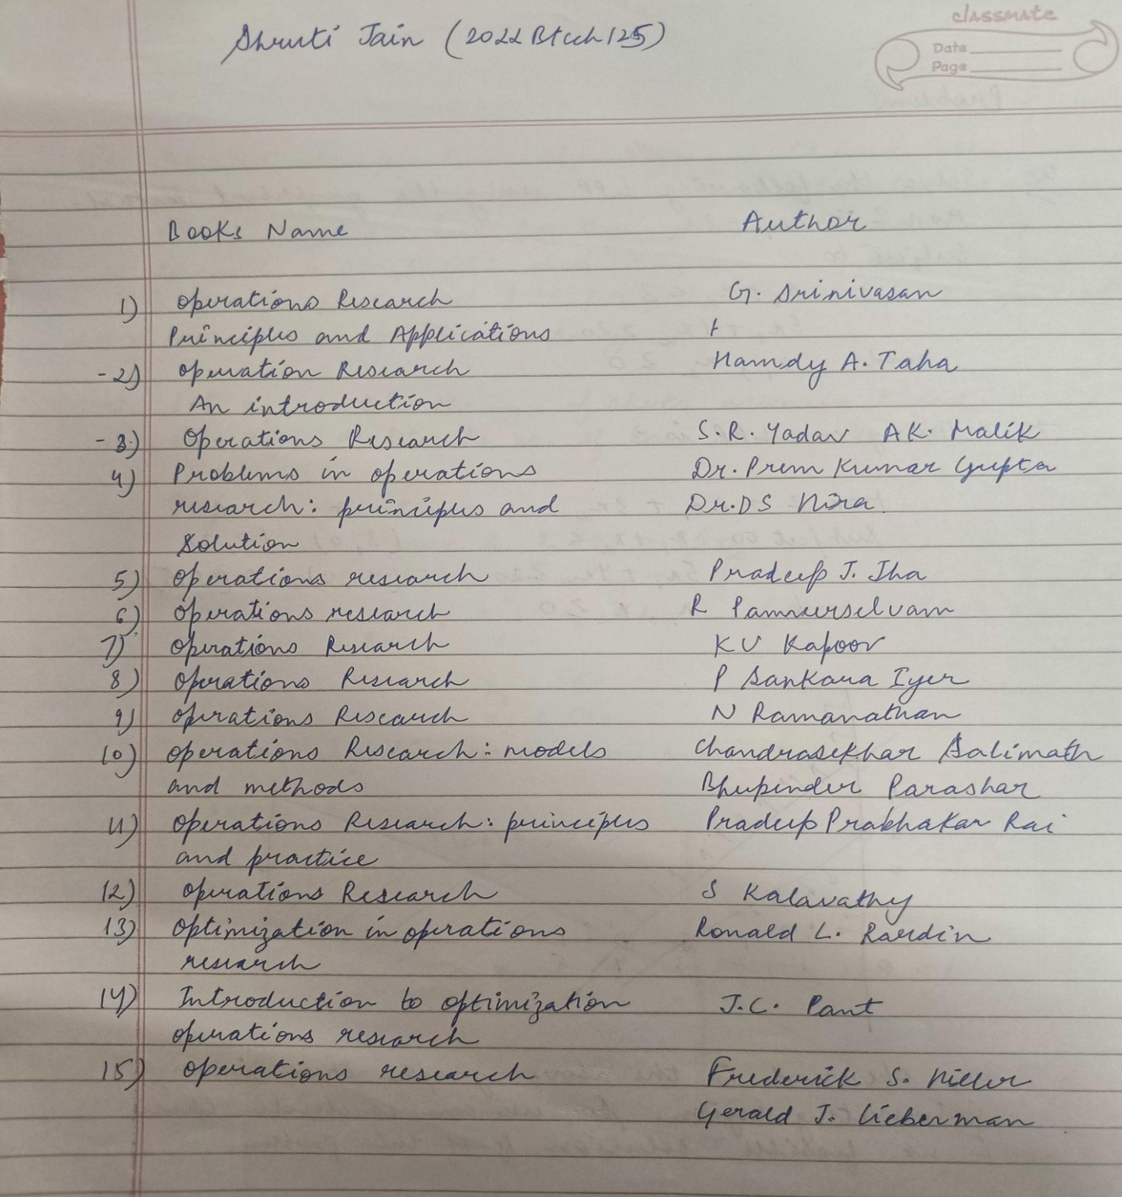

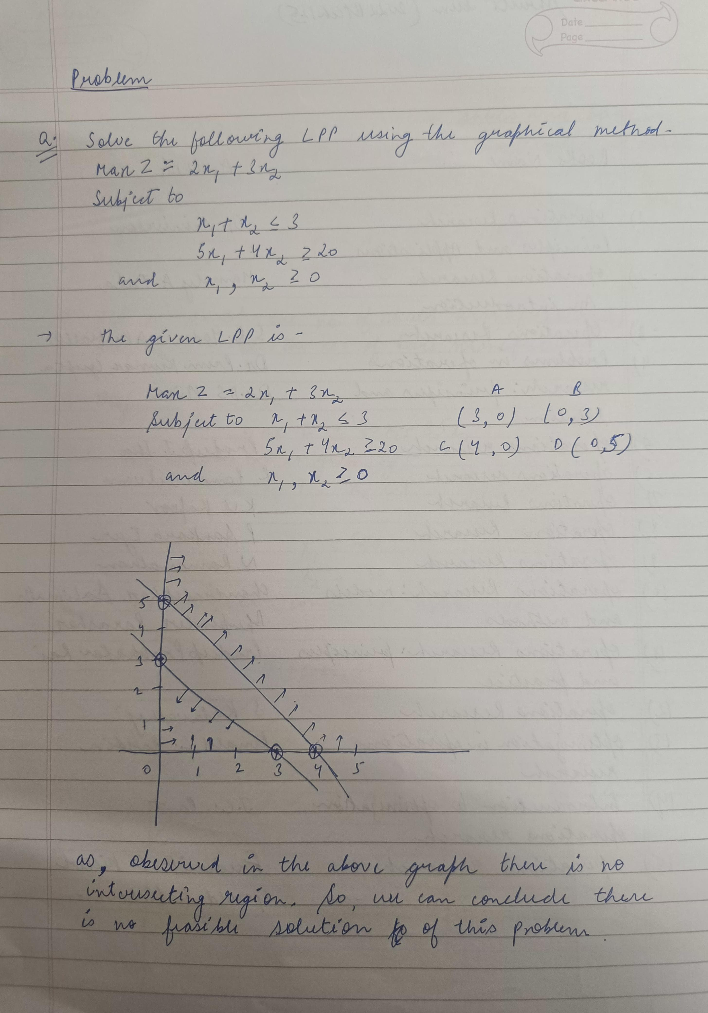

**PROBLEM 1- THE DIET PROBLEM**

To illustrate an application of linear programming in diet formulation:

Let us assume that a diet for justifiable reasons is restricted to skimmed milk and salad using well-known ingredients. We know that the nutritional requirements will be expressed as vitamin A and calcium controlled by their minimum quantities (in milligrams).

Table 1 summarizes the quality of each nutrient available in foods and their daily requirement for good health conditions of an individual, as well as the unitary cost of these foods. The objective is to minimize the total diet cost and comply with nutritional restrictions.

A. Cost, Nutrients and Predetermined Nutritional Restrictions

|  |  |  |  |
| --- | --- | --- | --- |
| **Nutrient** | **Milk (glass)** | **Salad (500 mg)** | **Minimum Nutritional requirement** |
| Vitamin A | 2 mg | 50 mg | 11 mg |
| Calcium | 50 mg | 10 mg | 70 mg |
| Cost /unit | Rs. 1.50 | Rs. 3.00 |  |

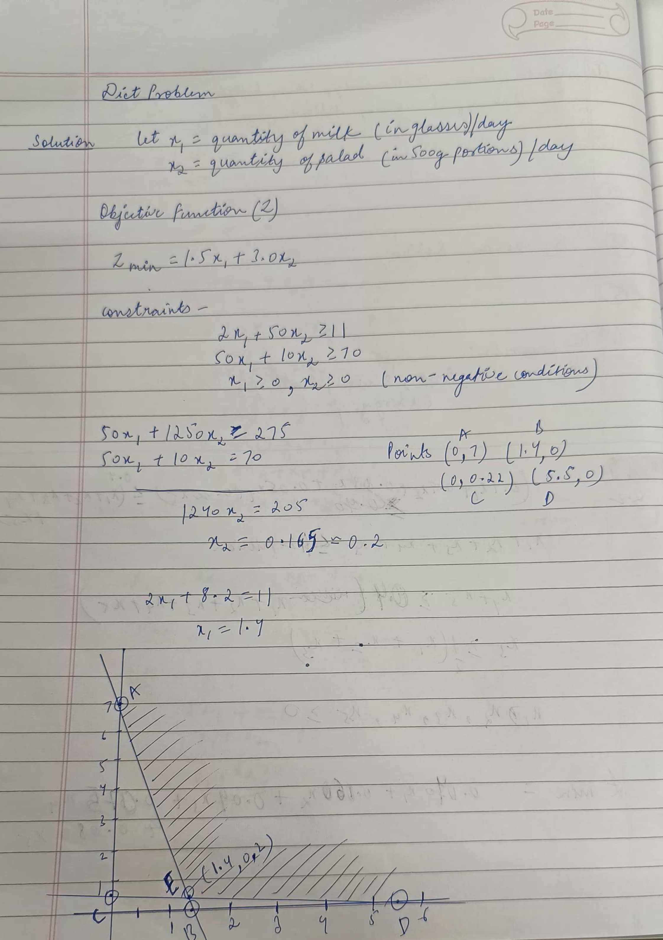

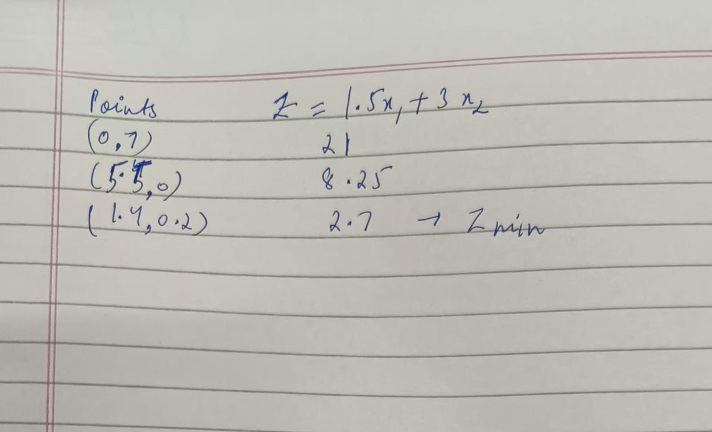

*Date: 18/01/24*

**LAB ACTIVITY 2**

Objective: Solving LPP using Tora software

**PROBLEM 1- THE DIET PROBLEM**

To illustrate an application of linear programming in diet formulation:

Let us assume that a diet for justifiable reasons is restricted to skimmed milk and salad using well-known ingredients. We know that the nutritional requirements will be expressed as vitamin A and calcium controlled by their minimum quantities (in milligrams).

Table 1 summarizes the quality of each nutrient available in foods and their daily requirement for good health conditions of an individual, as well as the unitary cost of these foods. The objective is to minimize the total diet cost and comply with nutritional restrictions.

A. Cost, Nutrients and Predetermined Nutritional Restrictions

|  |  |  |  |
| --- | --- | --- | --- |
| **Nutrient** | **Milk (glass)** | **Salad (500 mg)** | **Minimum Nutritional requirement** |
| **Vitamin A** | 2 mg | 50 mg | 11 mg |
| **Calcium** | 50 mg | 10 mg | 70 mg |
| **Cost /unit** | Rs. 1.50 | Rs. 3.00 |  |

Solution using Tora:

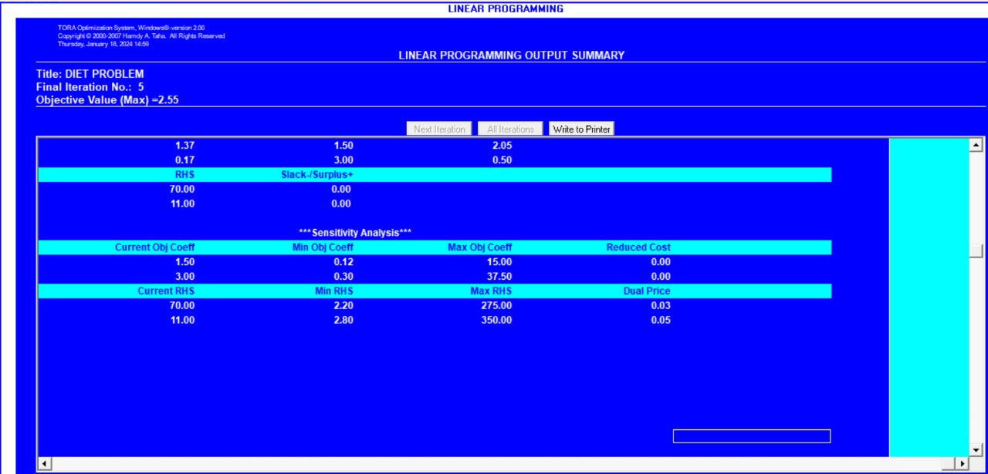

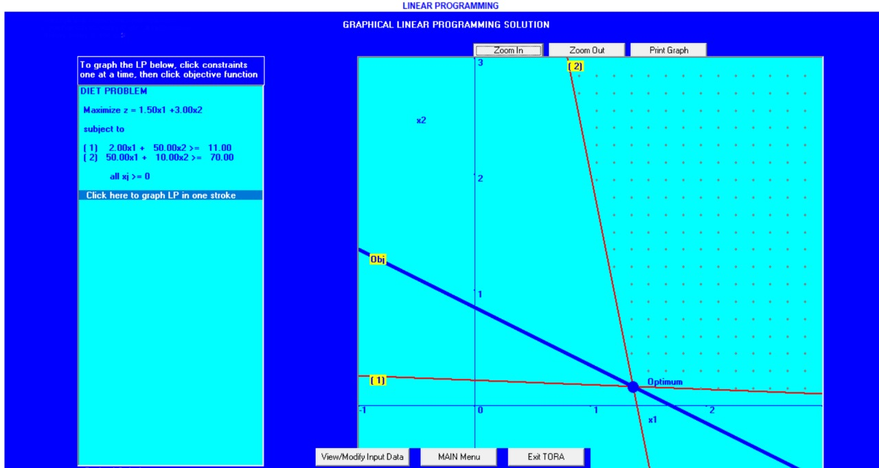

**PROBLEM 2 - DESCRIPTION OF THE PROBLEM OF HEALTHCARE RESOURCE ALLOCATION**

Researchers want to allocate resources among five medical intervention programs for a certain population aiming at maximizing the quality-adjusted life year (QALY). QALY is a measure that considers quality and quality of life-related to the medical intervention applied. It is estimated that a maximum of 300,000 monetary units be spent and the number of medical visits is expected to remain at 40,000, at most.

It is also assumed that each patient receives only one intervention. Moreover, fraction values of quality-adjusted life year QALY intervention costs and the number of medical visits are allowed. The objective is to maximize the total QALY accumulated by interventions to comply with the budget restrictions and the number of medical visits described in Table 2.

|  |  |  |  |
| --- | --- | --- | --- |
| **Identification of Intervention programs** | **QALY** | **Intervention cost (x103 monetary units) No. of medical visits (x103)** | **No. of medical visits (x10^3)** |
| 1 | 10 | 100 | 40 |
| 2 | 15 | 50 | 50 |
| 3 | 15 | 50 | 50 |
| 4 | 13 | 40 | 15 |
| 5 | 9 | 120 | 30 |
| Maximum value |  | 300 | 40 |

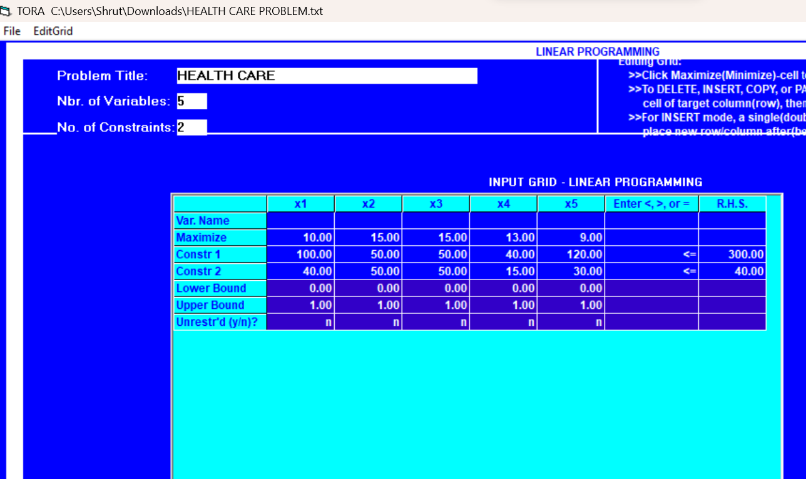

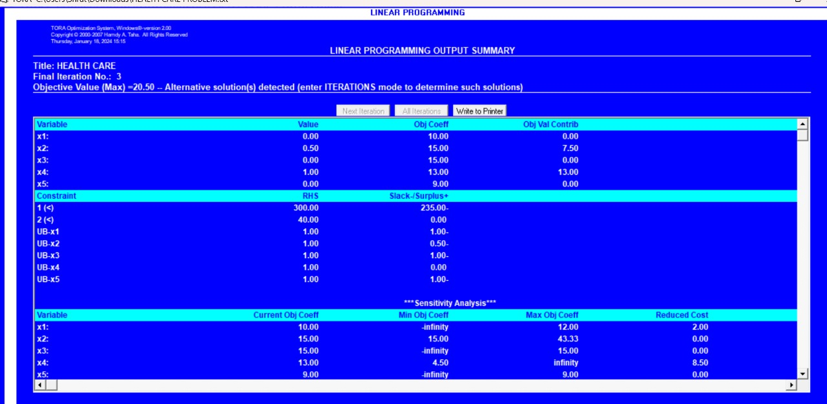

**PROBLEM 3: Case Study 1**

Giapetto’s Woodcarving manufactures two types of wooden toys: soldiers and trains. A soldier sells for $27 and uses $10 of raw materials. Each manufactured soldier increases Giapetto’s variable labour and overhead costs by $14. A train sells for $21 and uses $9 of raw materials. Each train built increases Giapetto’s variable labor and overhead costs by $10. The soldiers and trains require two types of skilled labour: carpentry and finishing. A soldier requires 2 hours of finishing labour and 1 hour of carpentry labour. A train requires 1 hour of finishing and 1 hour of carpentry labour. Each week, Giapetto can obtain all the needed raw materials but only 100 finishing hours and 80 carpentry hours. Demand for trains is unlimited, but at most 40 soldiers are bought each week. Giapetto wants to maximize weekly profit (revenues _ costs). How many of each toy should be made each week to maximize profits? Formulate the Mathematical LP Model of the Problem.

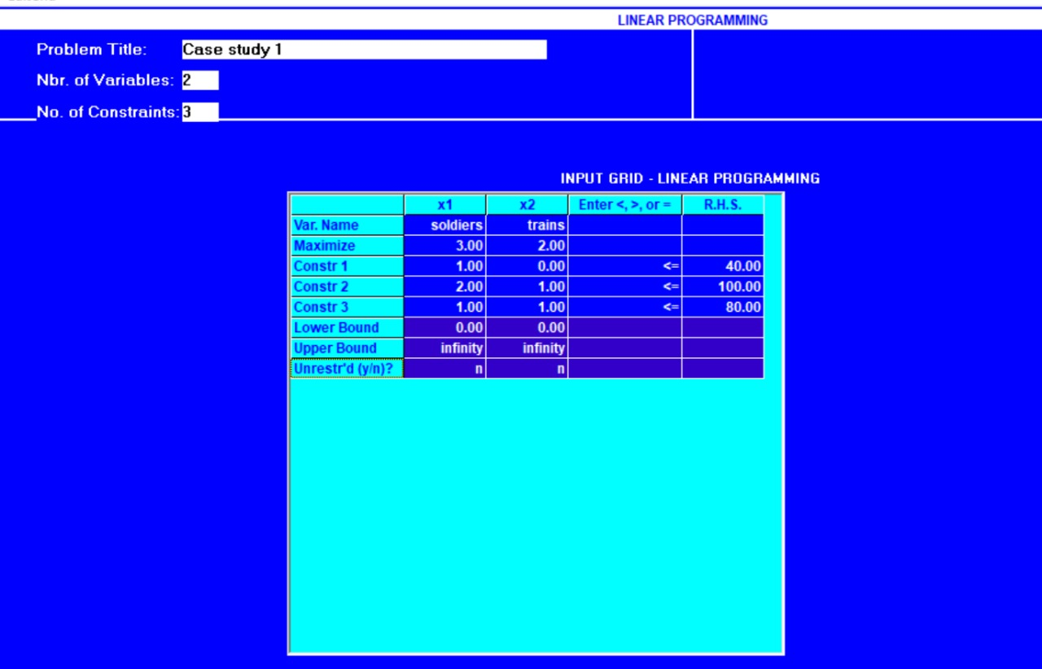

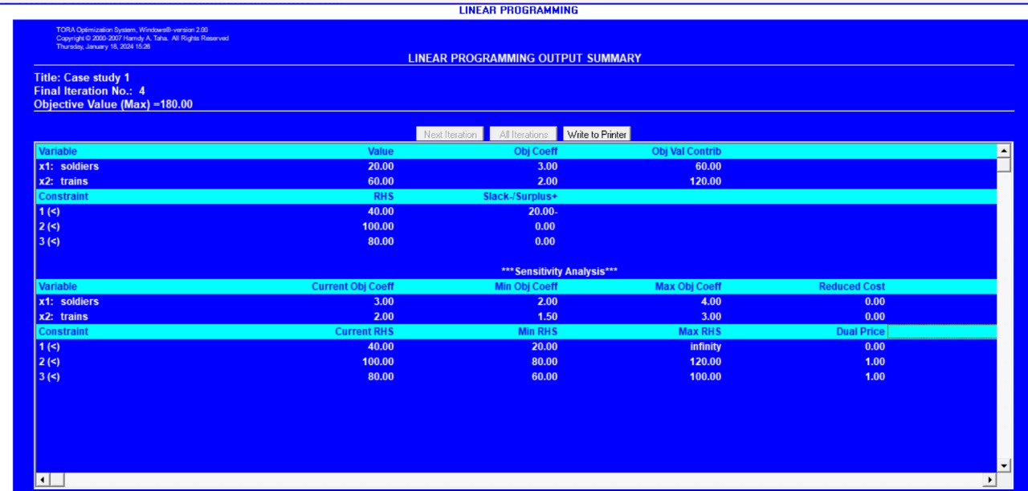

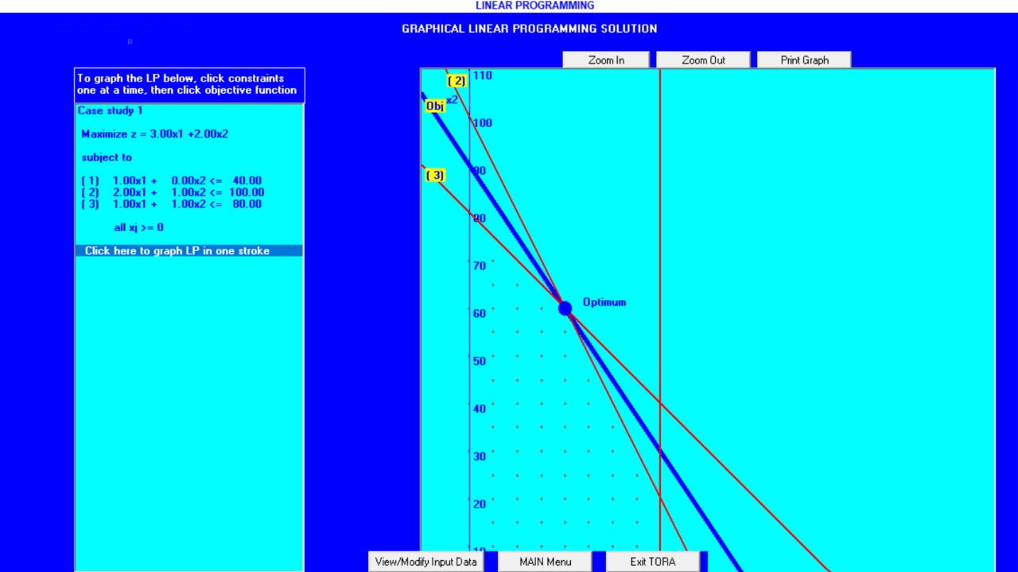

**PROBLEM 4: Case Study 2**

Thriftem Bank is in the process of devising a loan policy that involves a maximum of $12 million. The following table provides the pertinent data about available types of loans. Bad debts are unrecoverable and produce no interest revenue. Competition with other financial institutions requires that the bank allocate at least 40% of the funds to farm and commercial loans. To assist the housing industry in the region, home loans must equal at least 50% of the personal, car, and home loans. TIle Bank also has a policy of not allowing the overall ratio of bad debts on all loans to exceed 4%.

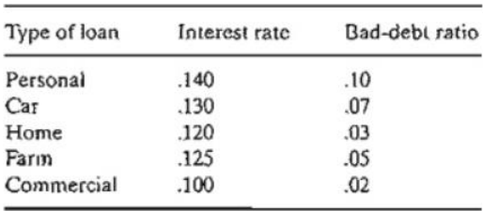

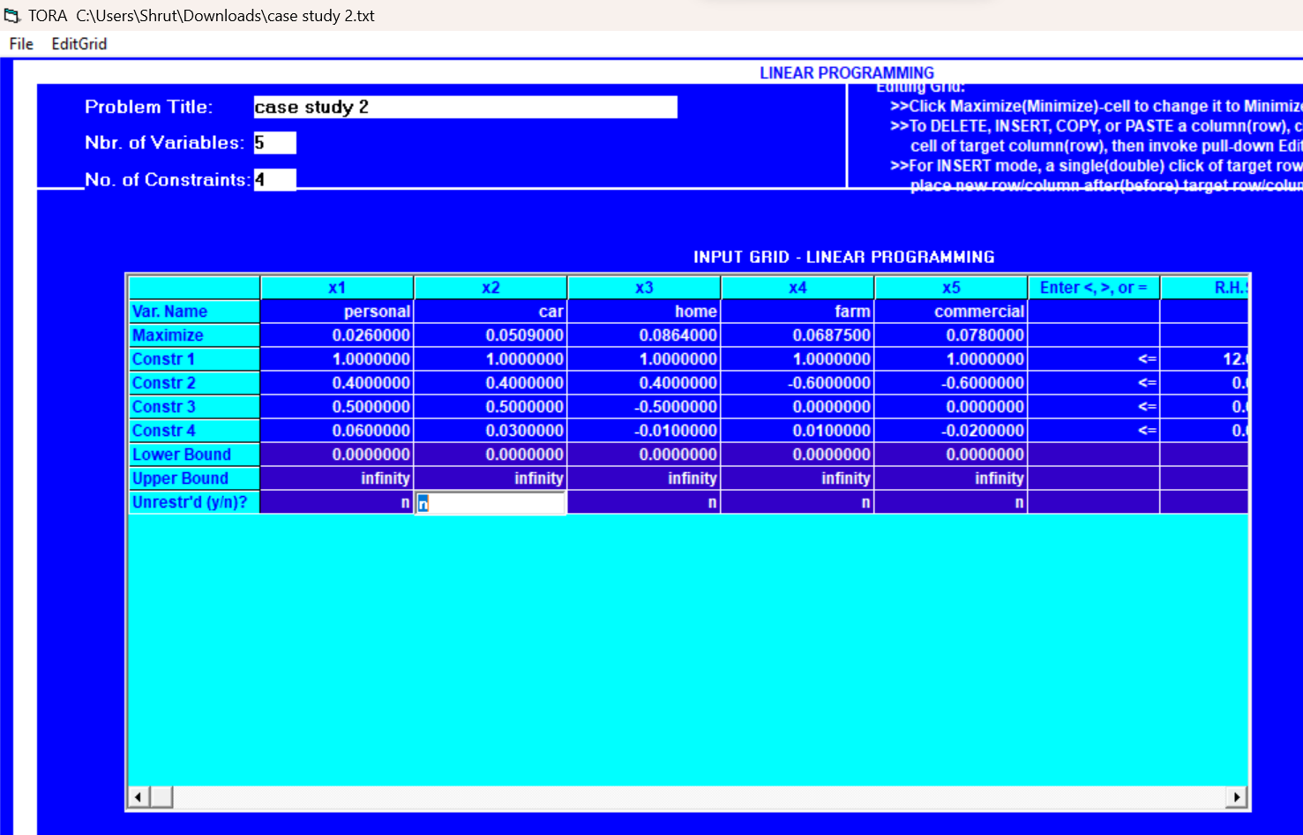

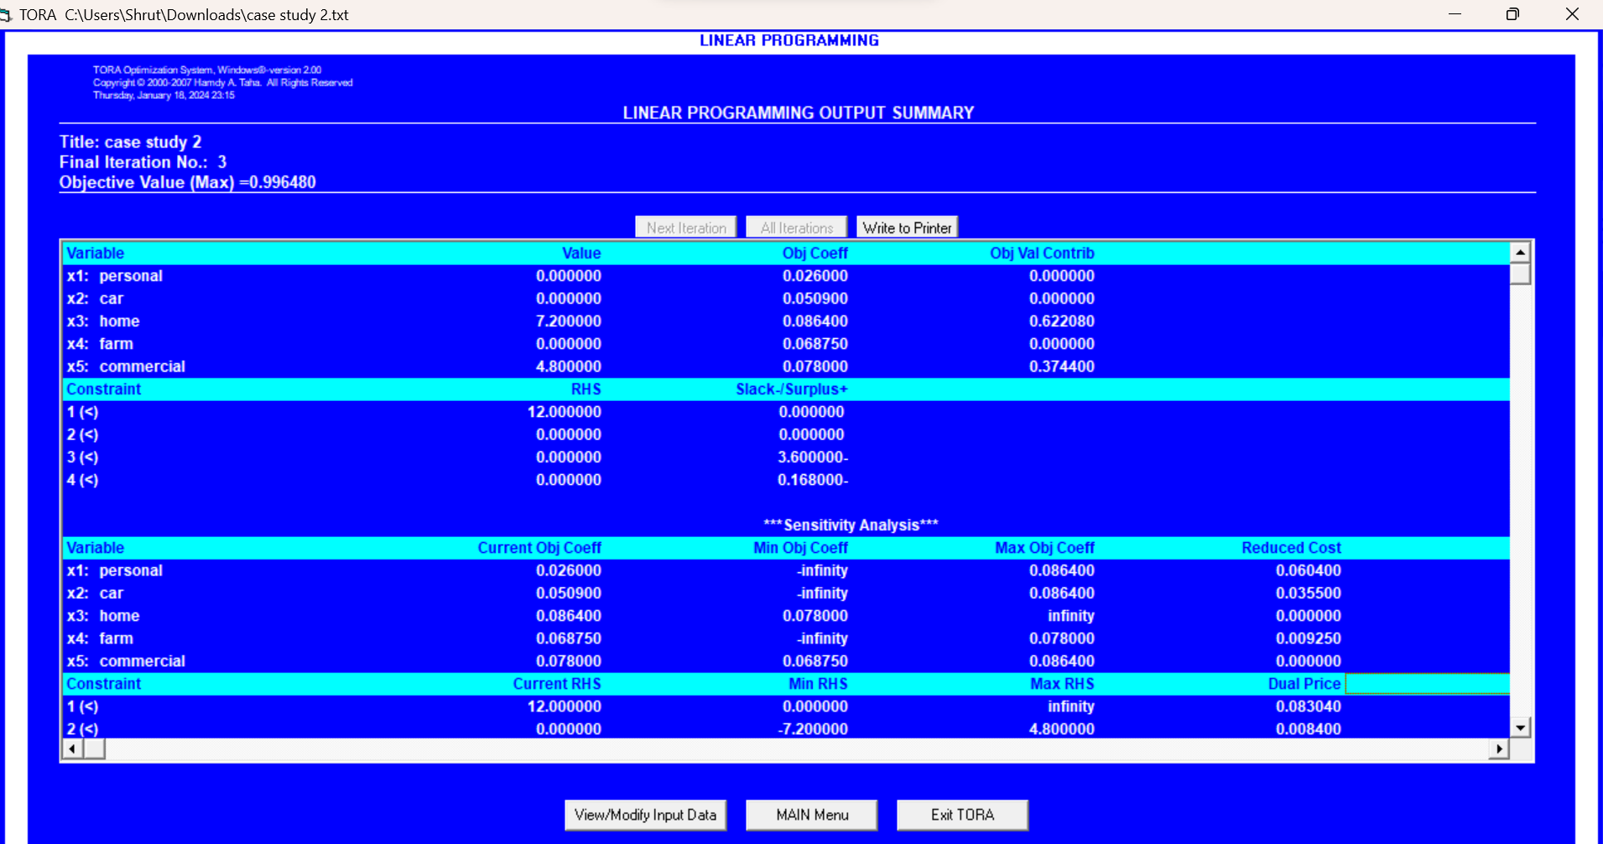

*Date: 25 /01/24*

**LAB ACTIVITY 3**

Objective: Solving linear programming problems using Python.

**#Problem 1**

#diet problem  
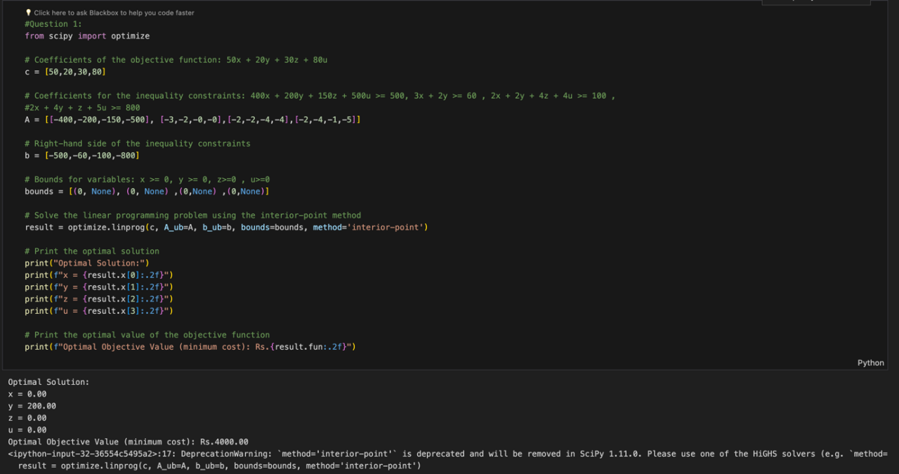

**#Problem 2**

#health care problem

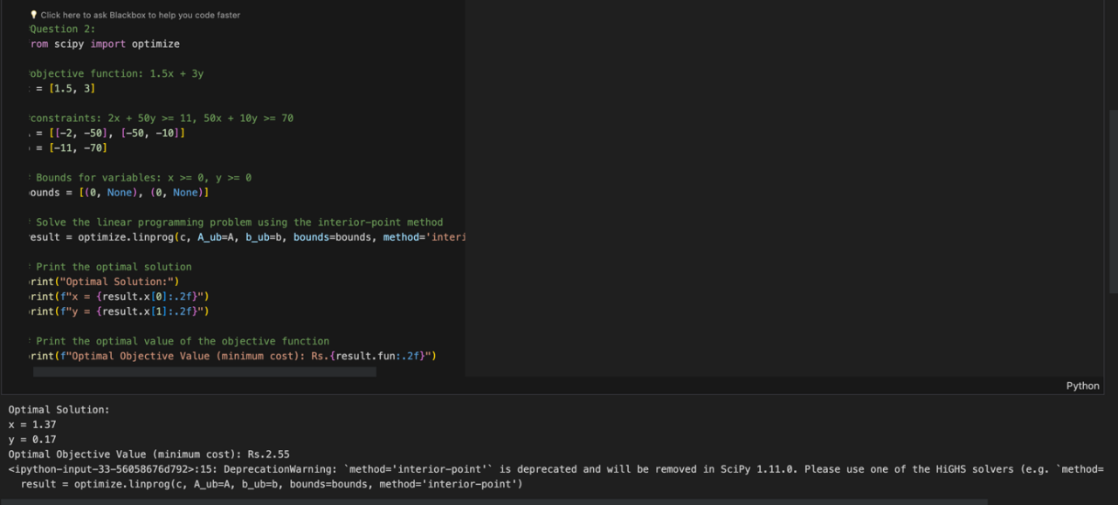

**#Problem 3**

#mr. Verma diet



*Date: 01/02/24*

**Lab activity 4**

Solving non-linear programming problem (Hessian matrix) using python  
#Problem 1

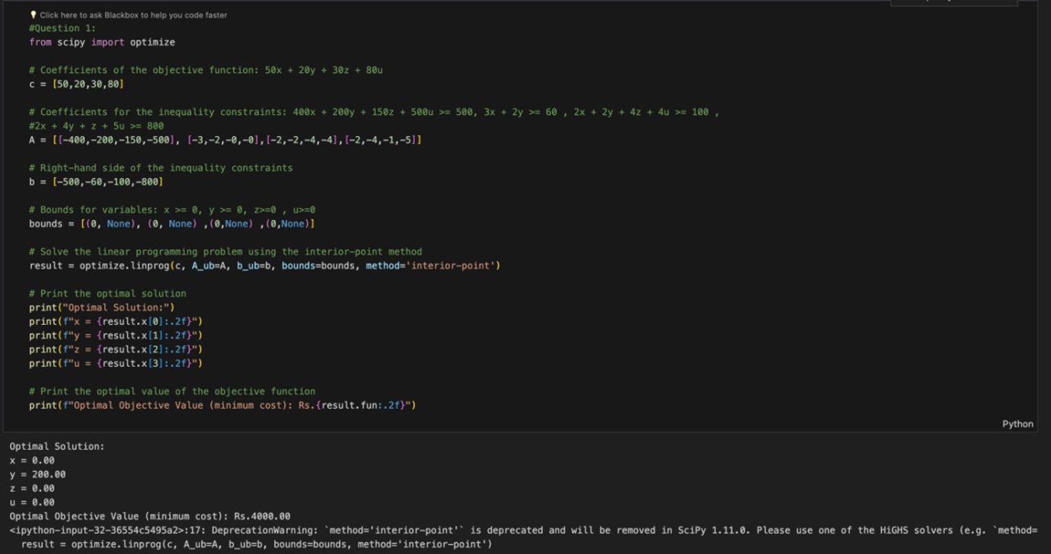

#Problem2

#Problem 3



*Date: - 08/02/24*

**LAB ACTIVITY 5**

Check convex or concave using python

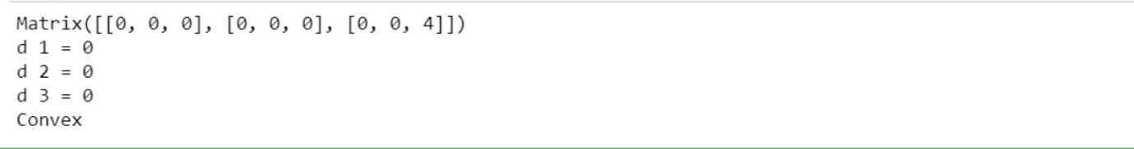

Case study:

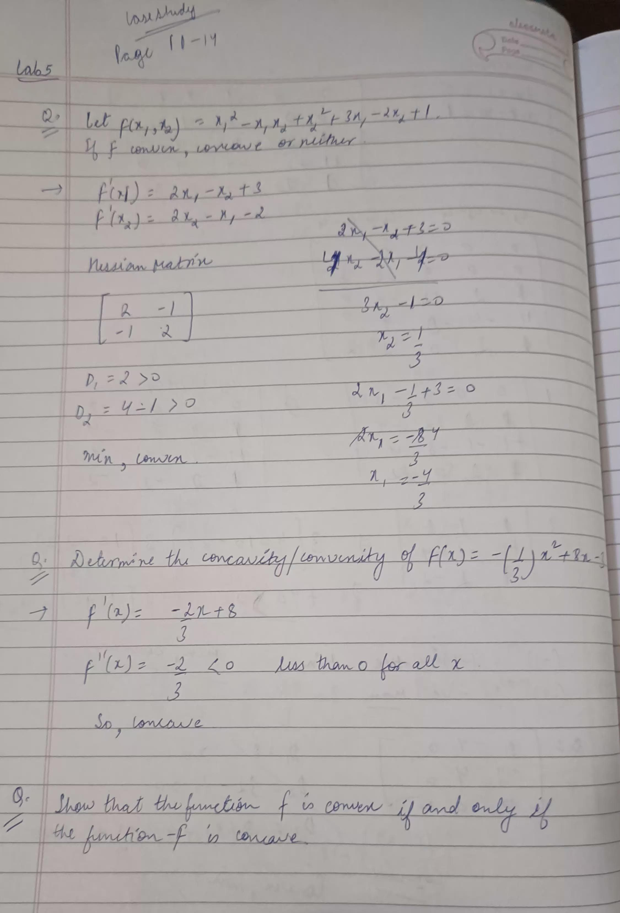

*Date: 22/02/24*

**Lab activity 6**

Objective: Analyzing Non-linear programming using the Lagrangian method through a research paper

#Problem 1



output generated

Optimized variables: [ 0.69983937 -2.60032126]

Optimized Lagrange multiplier: 4.68793967945987

Optimized objective function value: 3.1000002580250454

#Problem 2



output generated

Optimized variables: [ 0.6363618 -2.72727639]

Optimized Lagrange multiplier: 4.661852309649863

Optimized objective function value: 3.5454545454914417

#Problem 3

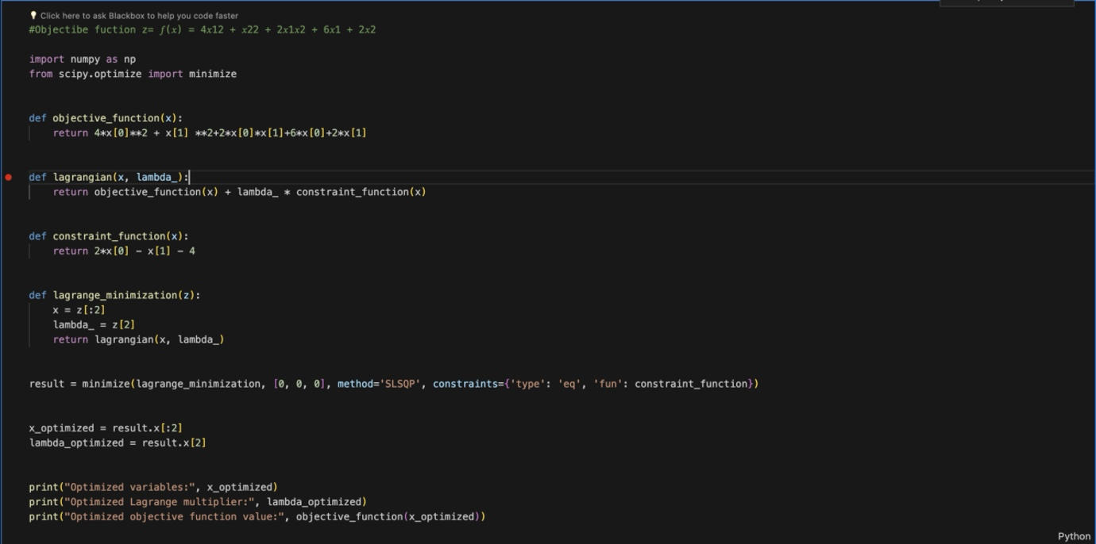

output generated

Optimized variables: [ 0.58322133 -2.83355734]

Optimized Lagrange multiplier: 4.625214264102916

Optimized objective function value: 3.9166668172023247

*Date: 07/03/24*

**LAB ACTIVITY 7**

Minimization of function by Golden section method using Python

Python code:

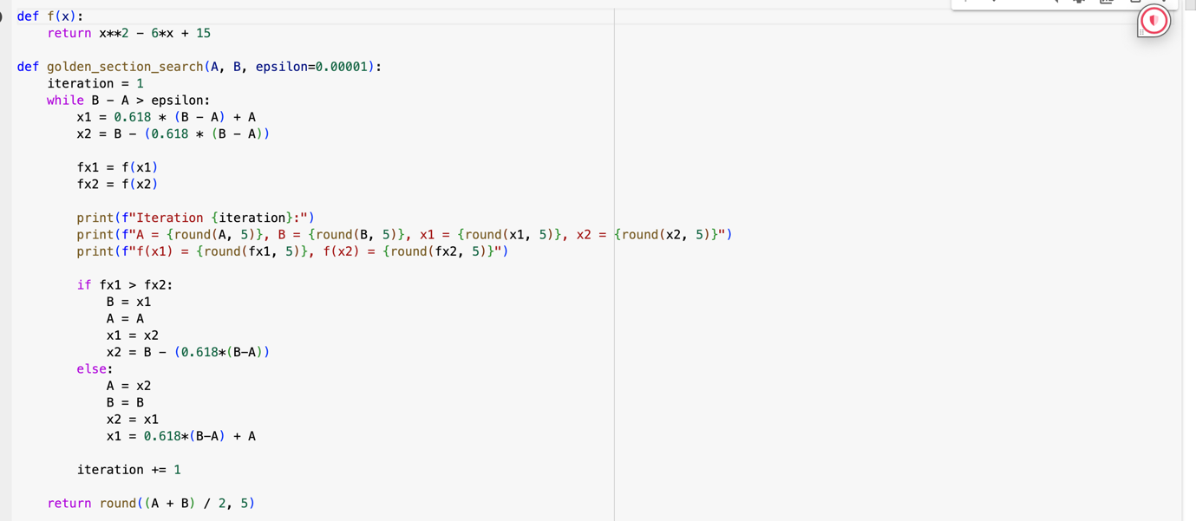



Output: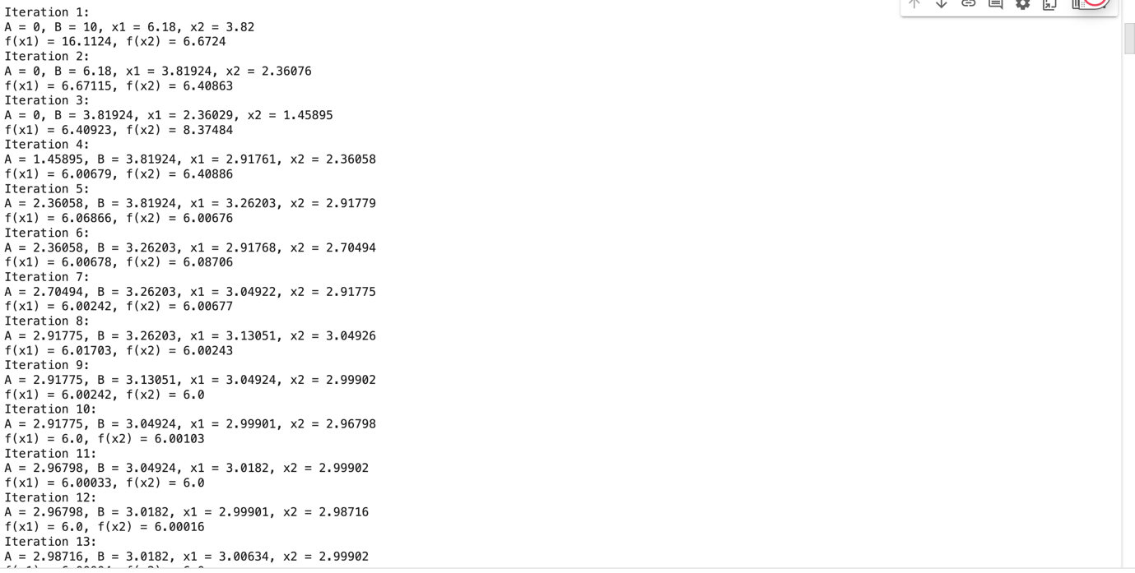



*Date: 28/03/24*

**LAB ACTIVITY 8**

Fibonacci method:



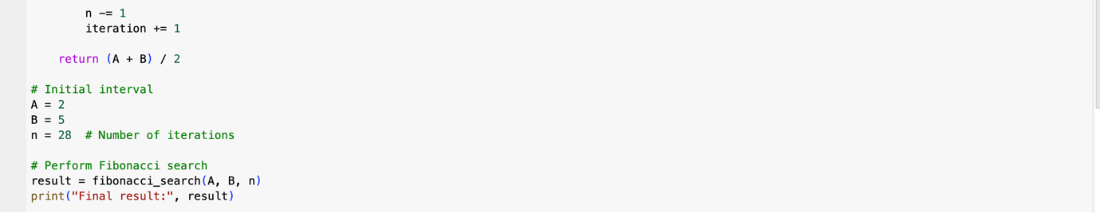

Output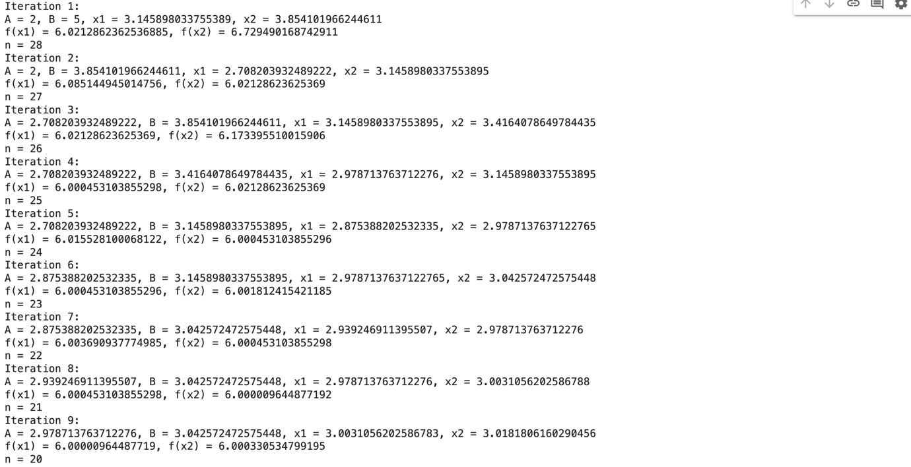

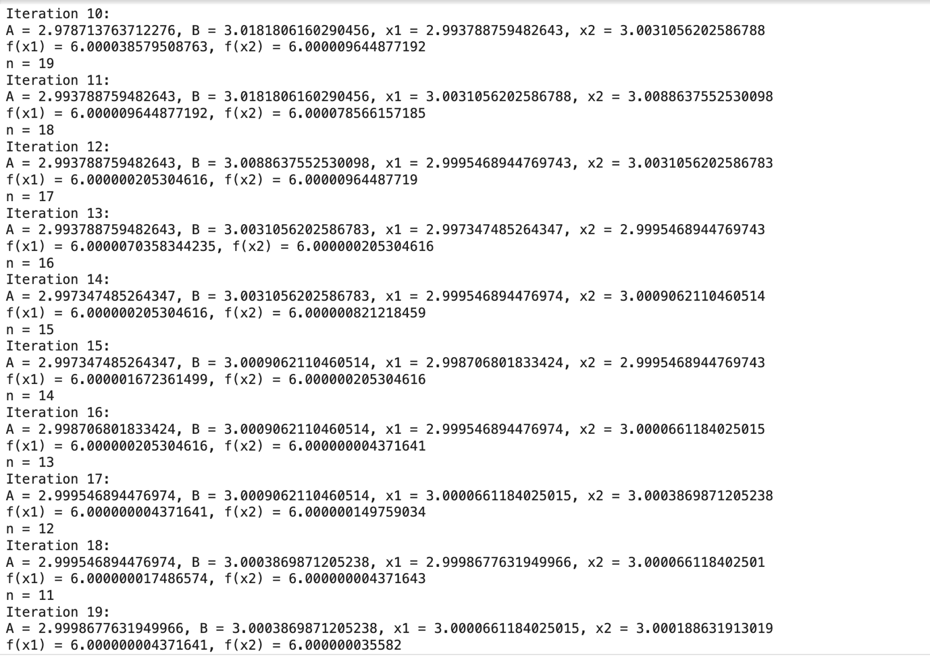

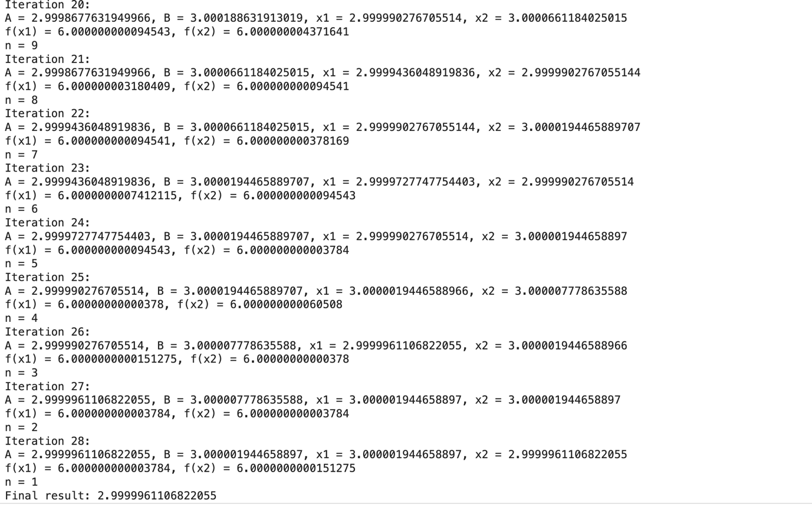

*Date: 04/04/24*

**Lab activity 9**

Steepest descent method

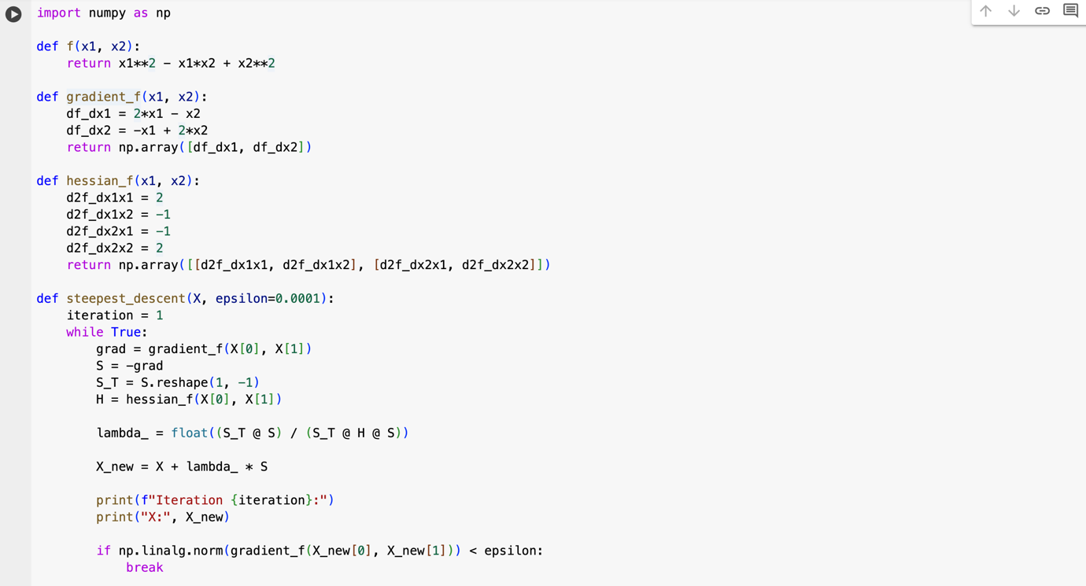



Output:  


Newton Search Method

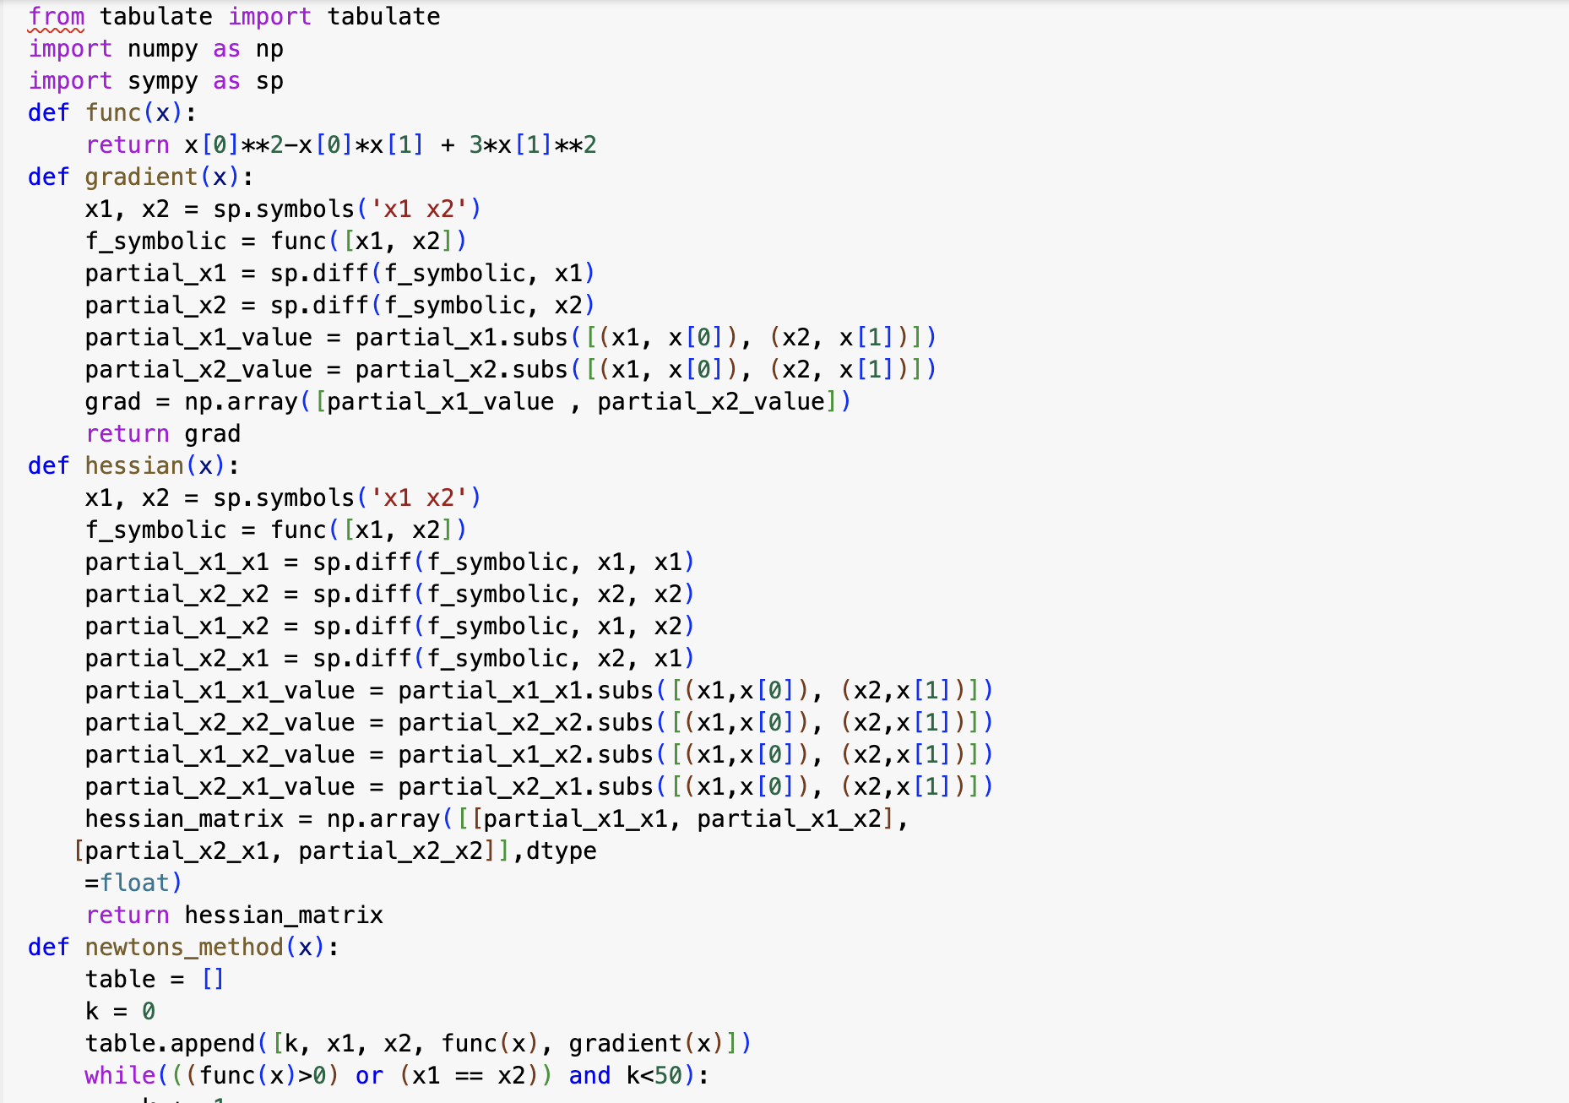



Output:

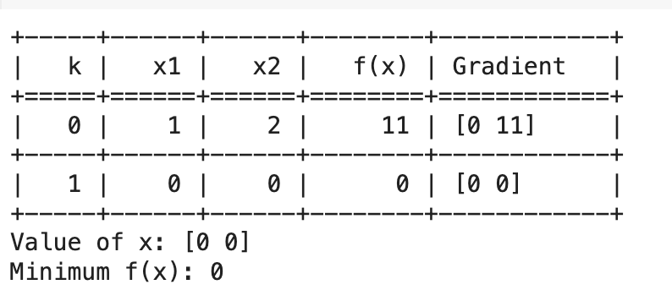

*Date: 11/04/24*

**Lab activity 11**

Conjugate Search Method

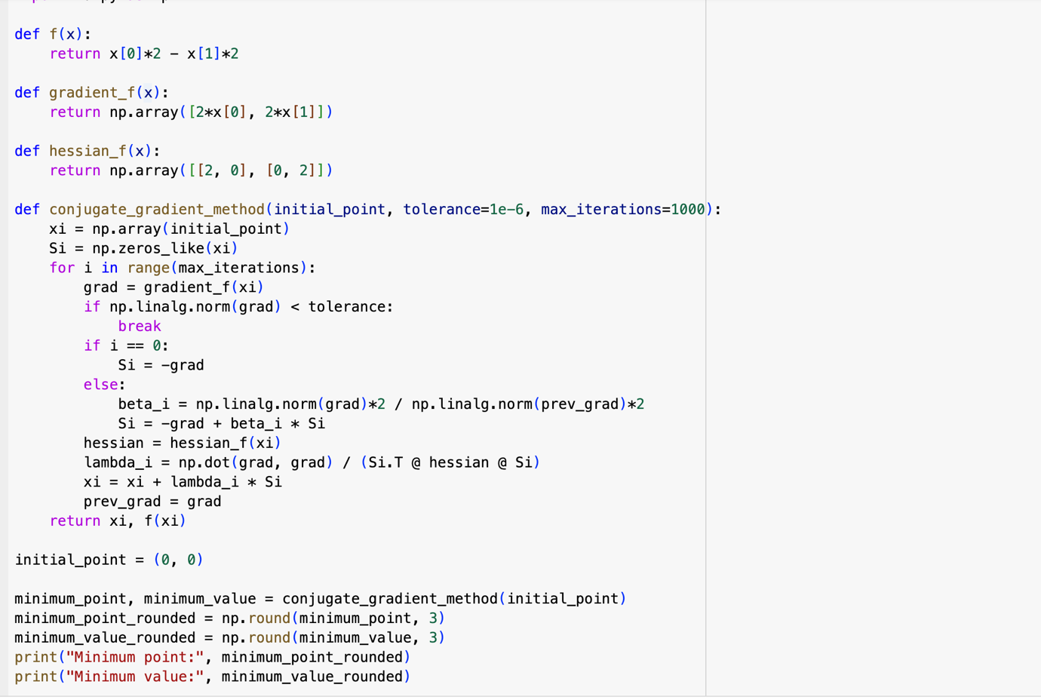

Output:

